November 1, 2023
Ref: IIH/MD/2023/11/002
Hawa Mamud,
Akadeemia Tee 11-522,
Ehitajate, Harjumaa, Tallinn.
OFFER OF APPOINTMENT
I write to inform you of our decision to offer you an appointment to the position of Programs and Partnerships Officer at the Ilorin Innovation Hub starting from Monday November 1, 2023. Your job description and responsibilities will be communicated on acceptance of this offer.
Kindly respond with your acceptance in writing by Friday November 3, 2023.
We are starting exciting new ventures in Ilorin and are looking forward to working with you to make our dreams a huge success.
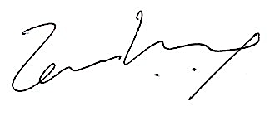
Yours sincerely,

Temi Kolawole
ag. Managing Director
Ilorin Innovation Hub

